Assignment 1: Displaying Bank Nam and Bank Address as a String

Restful URL 1:

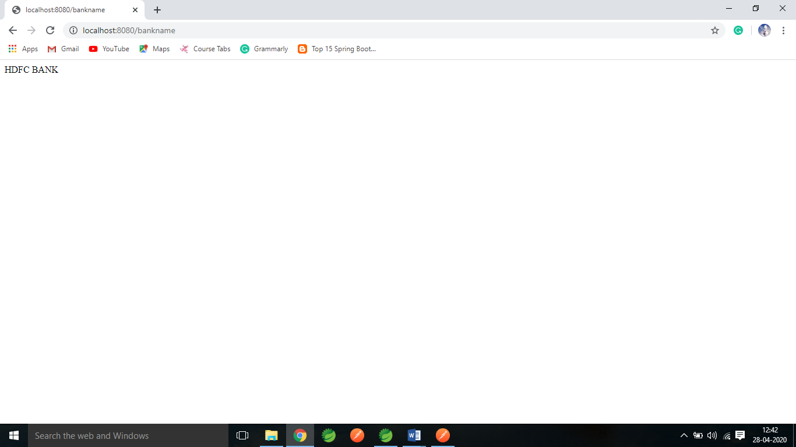

Restful URL 2:

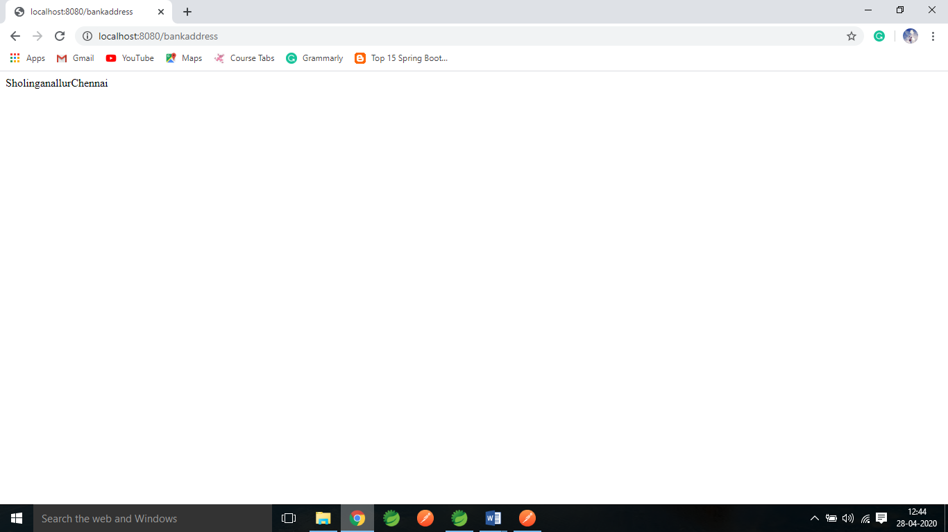

Assignment2: Displaying Bank Branch and Service Details in Table.

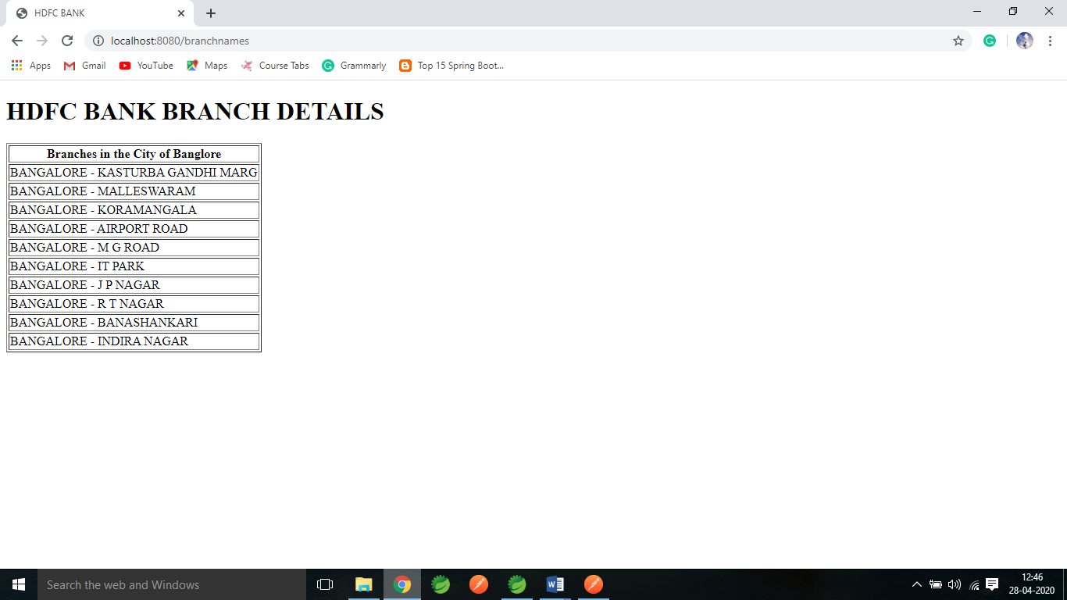

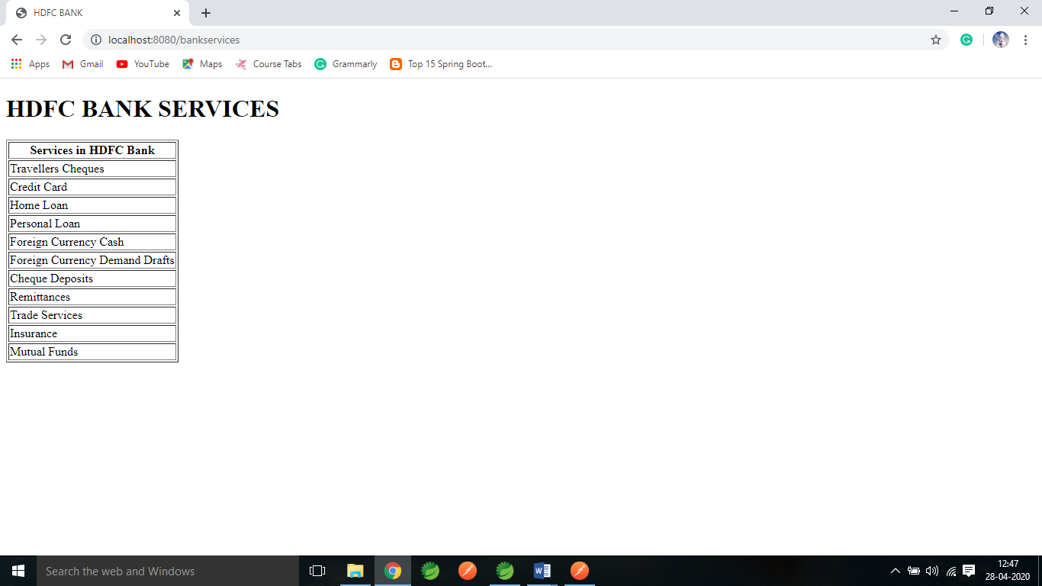

Assignment 3: To Check the health of the Application

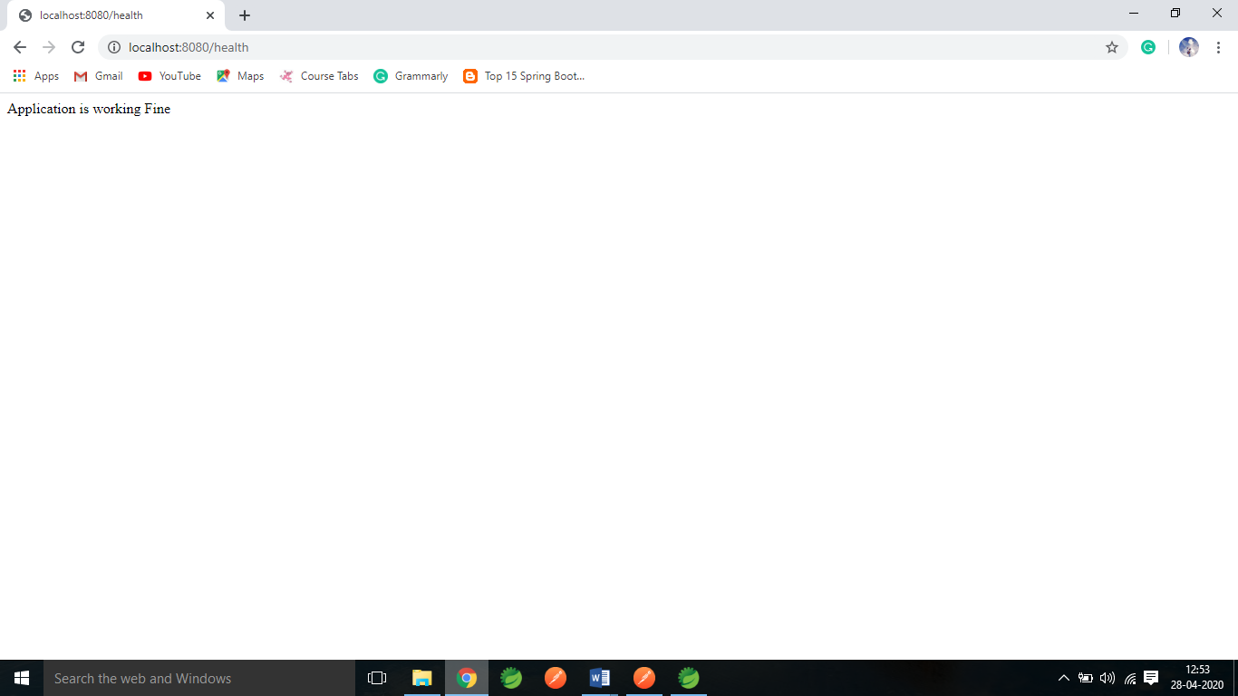

Assignment 4: Adding Employee to DB and displaying all User Details

Add Employee Screen:

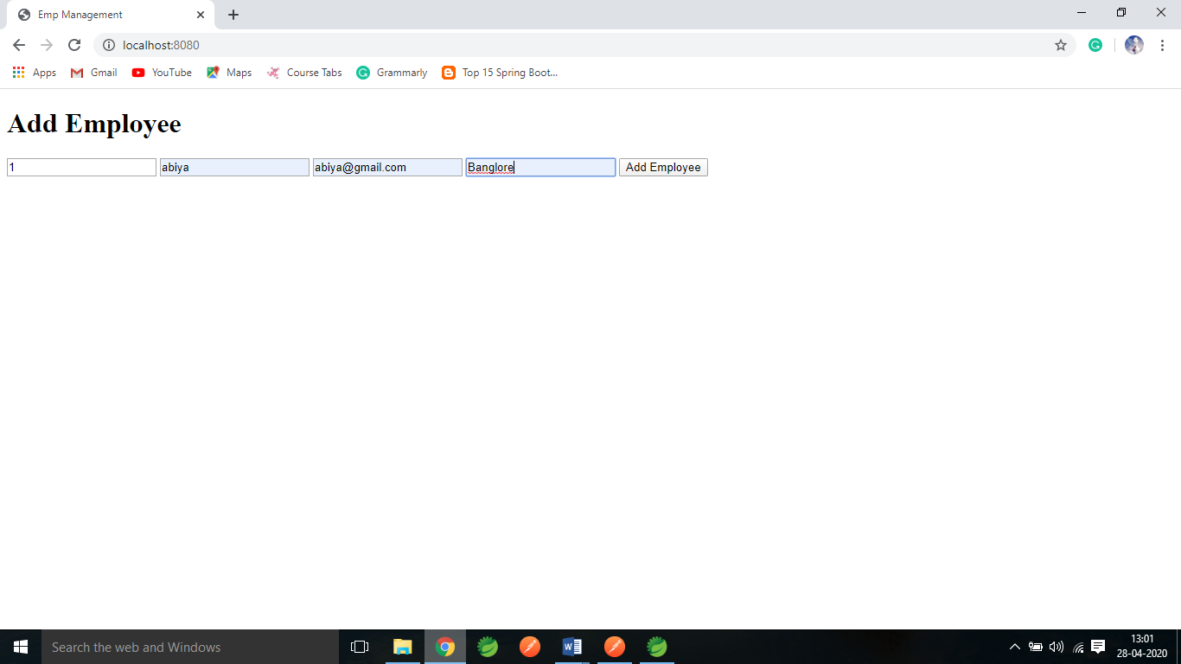

After Adding:

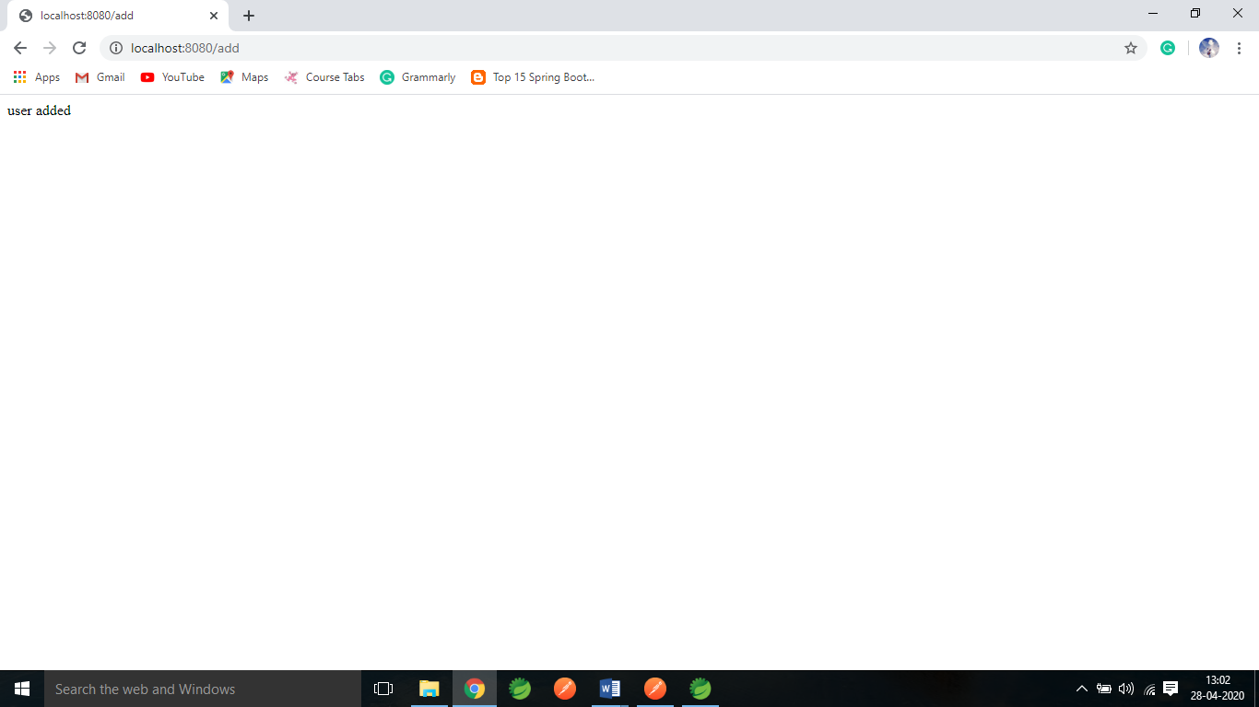

Displaying All Employee Details

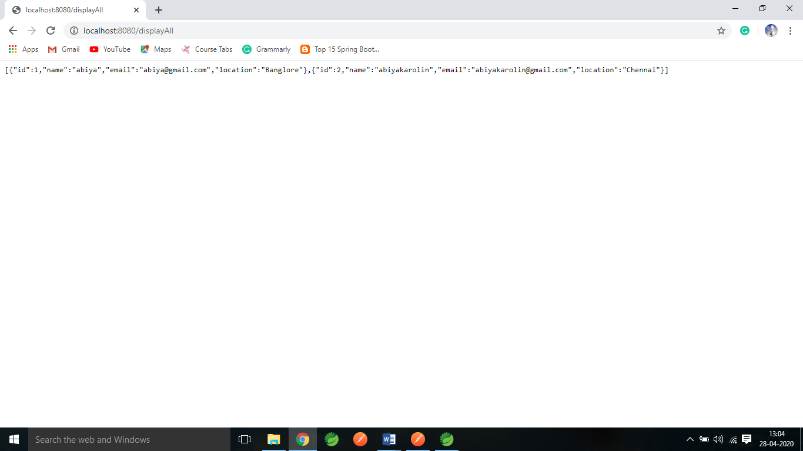

Displaying the Employee details using Id:

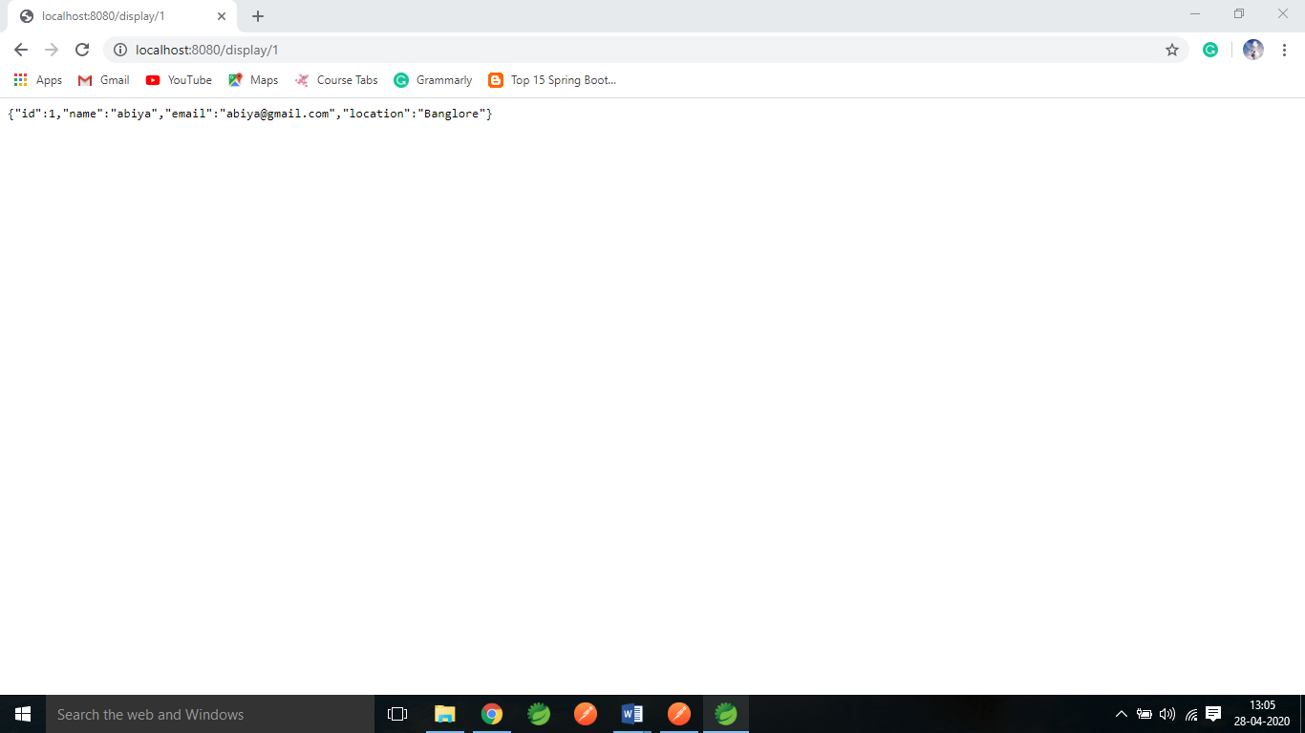

Assignment 5: Working on CRUD Operations

Adding Data using POST Method:

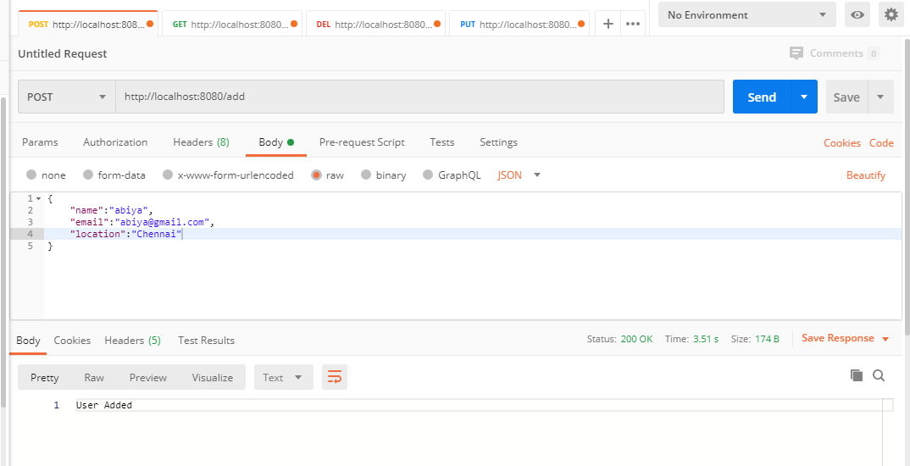

Displaying the details using GET Method

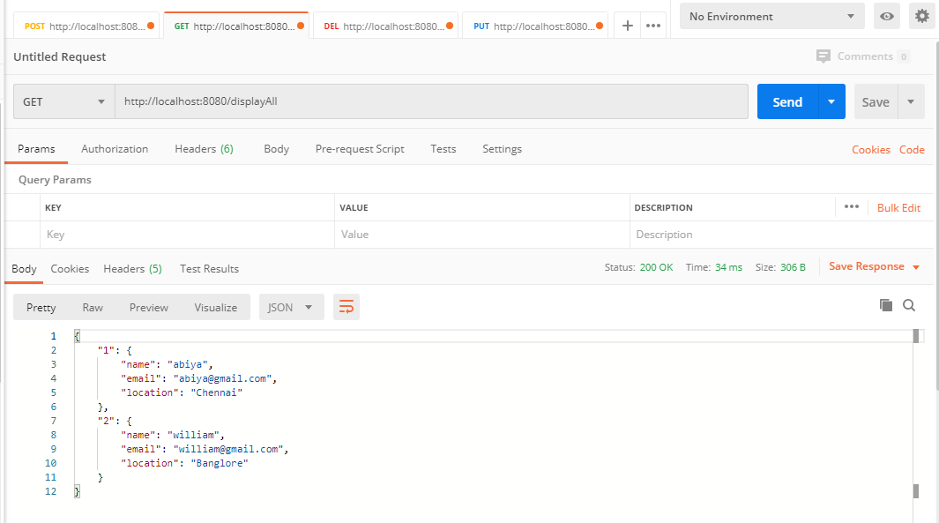

Editing the Employee Details using Id and PUT Method

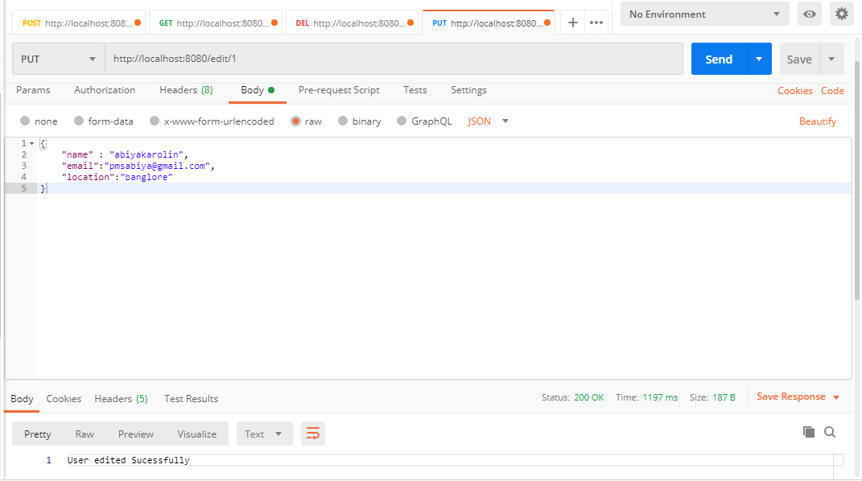

After a Successful Update

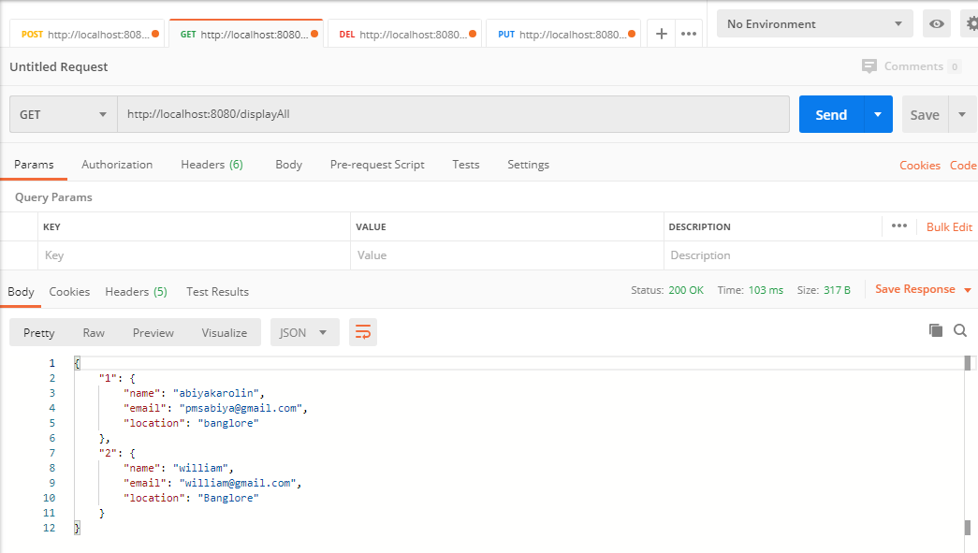

Deleting the Employee Details Using ID and Delete Method

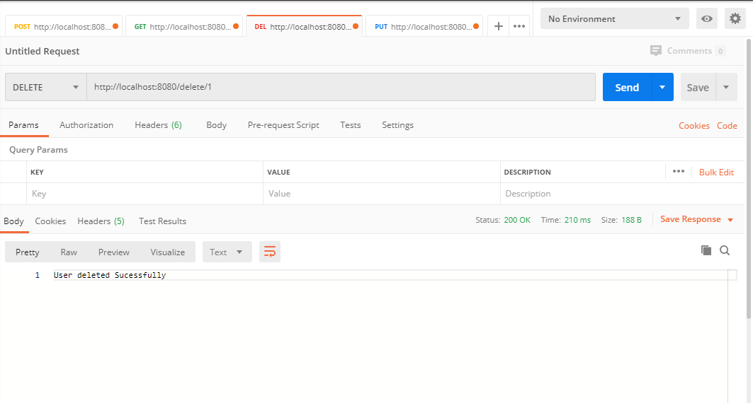

After Successful Delete:

